Advanced Computer Network

PRACTICAL NO 4

027_Abhishek_Ojha

**Practical No 4**

**Aim:** Create DHCP server and client for DHCP service.

**Configuration of DHCP Client and Server**

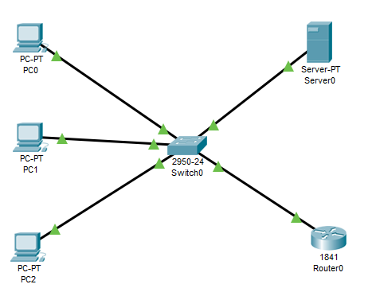

**On PC0:**

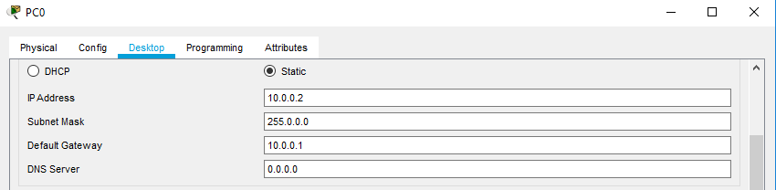

**On PC1:**

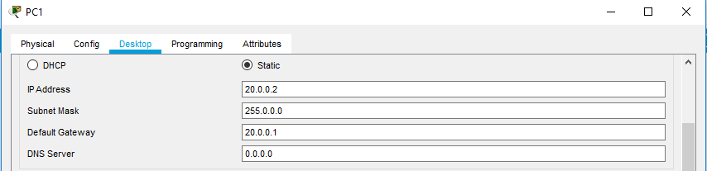

**On PC2:**

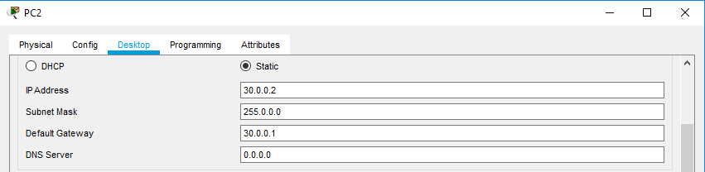

**On Router0:**

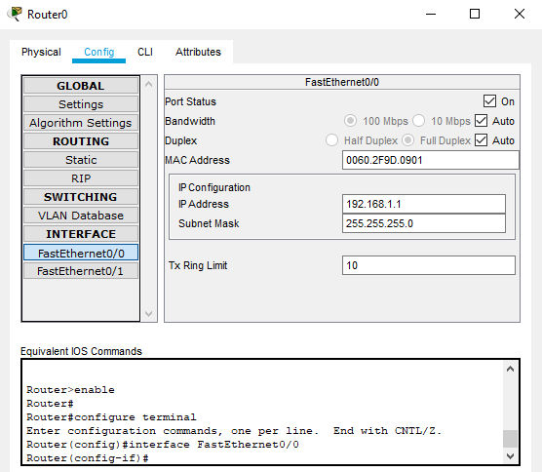

**Setup IP on Server0:**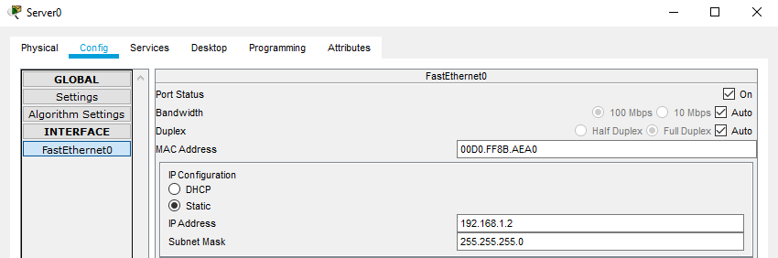

**Setup DHCP on Server0:**

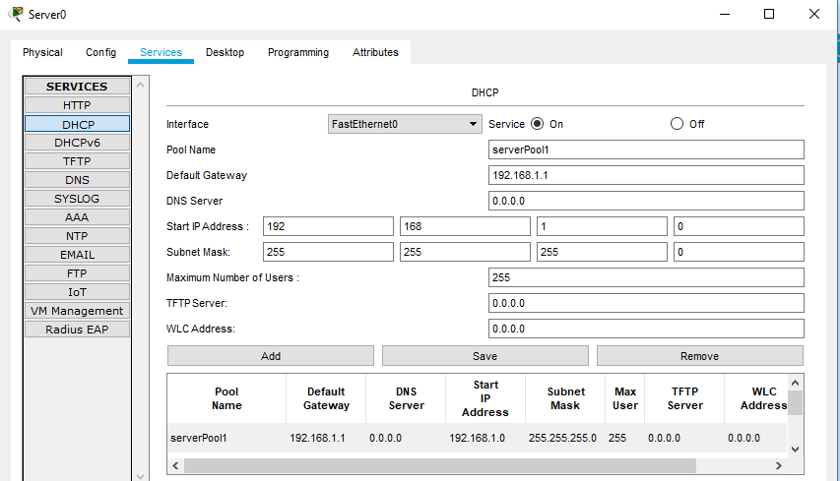

**Now go to PC0 and select DHCP:**

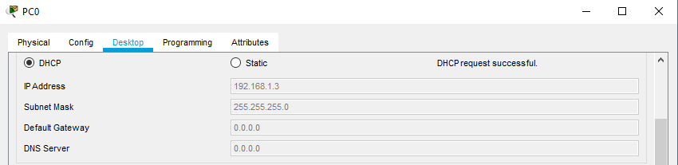

**Now, open web browser on PC0 and enter the Server IP Address:**

